**Footer customization**

* New files that are added in template folder
  + init_custom.vm
  + widgets-footer.vm
* Footer styles are added at the end of custom.css
* Theme settings are updated in liferay-look-and-feel.xml
* Footer code is embedded in portal_normal.vm

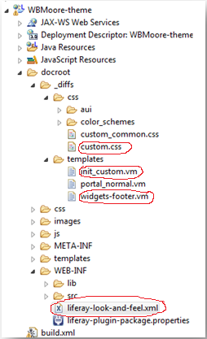

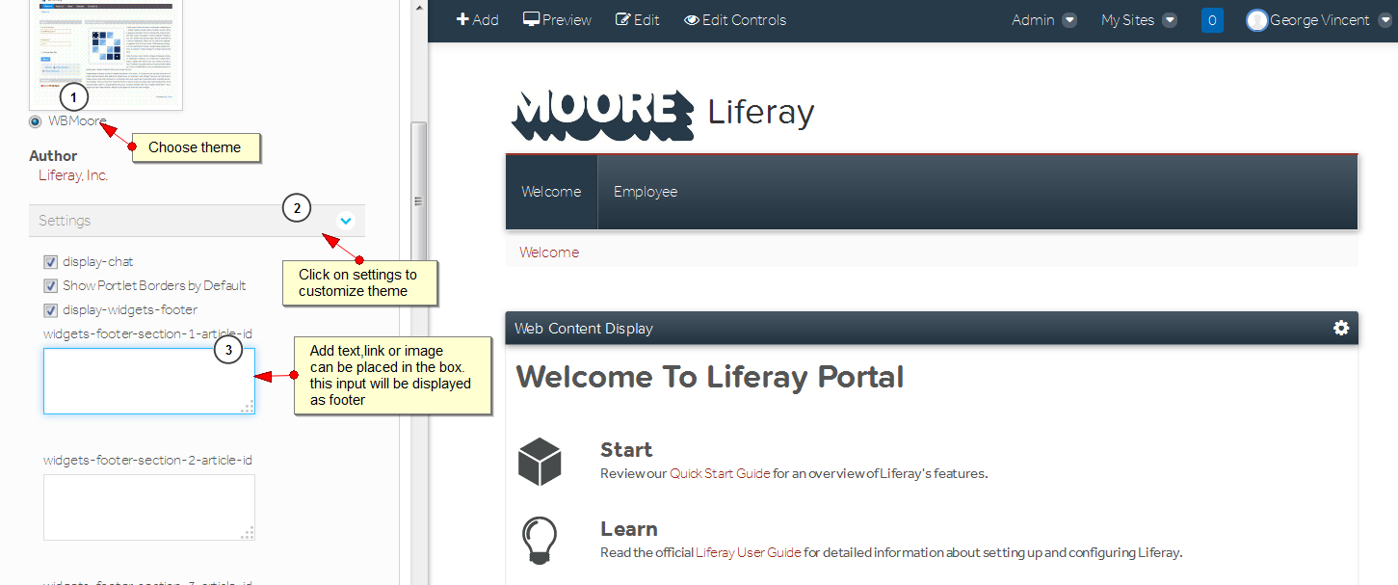

**Footer Section contents given below**

**Widget Footer section 1**

<div class="footer">Document management</div>

<a href="" class="foot">Projects</a>

<a href="" class="foot">Policies</a>

<a href="" class="foot">File Manager</a>

**Widget Footer section 2**

<div class="footer">Applications</div>

<a href="" class="foot">ComputerEase</a>

<a href="" class="foot">AutoCD</a>

**Widget Footer section 3**

<div class="footer">Collaboration</div>

<a href="" class="foot">General company Wiki</a>

<a href="" class="foot">Estimating Wiki</a>

<a href="" class="foot">Enginnering Wiki</a>

<a href="" class="foot">Project Wiki</a>

**Widget Footer section 4**

<div class="footer">Locations</div>

<a href="" class="foot">Virginia</a>

<a href="" class="foot">North Carlolina</a>

<a href="" class="area">Charlotte Area</a>

<a href="" class="area">Raleigh Area</a>

<a href="" class="foot">South Carolina</a>

<a href="" class="area">Georgia</a>

**Widget Footer section 5**

<div class="footer">Departments</div>

<a href="" class="foot">HR</a>

<a href="" class="foot">Accounting</a>

<a href="" class="foot">Engineering</a>

<a href="" class="foot">Project Management</a>

<a href="" class="foot">Warehouse</a>

**Widget Footer section 6**

<div class="footer">Directory</div>

<a href="" class="foot">Company</a>

<a href="" class="foot">Vendors</a>

<a href="" class="foot">Customers</a>

**Widget Footer section 7**

<img src="http://192.168.1.124:8080/image/layout_set_logo?img_id=22914&t=1437554137960" hight="65" width="155"/><br>

<div class="challenge">Challenge - Safety- Community</div>

Once done save settings and refresh page you will get footer will appear like this

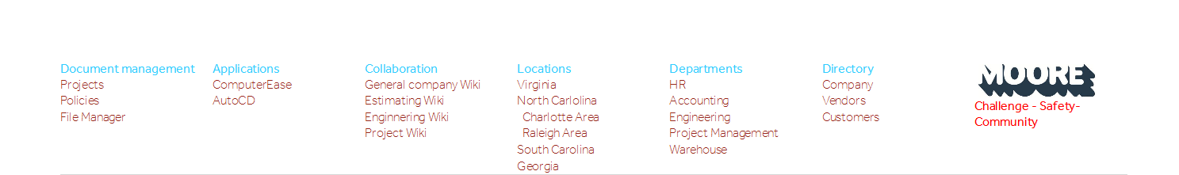

Each page can have its own footer. Department site admin can change footer link at any point of time